A Project Report

On

“AI-Based Crypto-Currency Trading System”
By
Rushabh Mahesh Sanghvi

Under the esteemed guidance of
Prof. Prajakta Bhadekar
Assistant Professor

DEPARTMENT OF DATA SCIENCE
Vishnu Waman Thakur Charitable Trust’s
Bhaskar Waman Thakur College of Science,
Yashvant Keshav Patil College of Commerce,
Vidhya Dayanand Patil College of Arts.
(VIVA College)
(Affiliated to University of Mumbai)
Virar West, 401303
Maharashtra

2025-2026
Vishnu Waman Thakur Charitable Trust’s
Bhaskar Waman Thakur College of Science,
Yashvant Keshav Patil College of Commerce,
Vidhya Dayanand Patil College of Arts.
(VIVA College)
Affiliated to University of Mumbai
Virar West, 401303
Maharashtra

DEPARTMENT OF DATA SCIENCE
CERTIFICATE
Roll No. 36
This is to certify that the project entitled, “AI-Based Crypto-Currency Trading System", is bonafied work of Rushabh Mahesh Sanghvi bearing submitted in partial fulfillment of the requirements for the award of degree of BACHELOR OF SCIENCE in DATA SCIENCE from University of Mumbai.

Internal Guide

Date:

External Examiner

Head of Department

College Seal

DECLARATION

I hereby declare that the project entitled, “AI-Based Crypto-Currency Trading System” done at “Vishnu Waman Thakur Charitable Trust’s Bhaskar Waman Thakur College of Science, Yashwant Keshav Patil College of Commerce, Vidya Dayanand Patil College of Arts”, has not been in any case duplicated to submit to any other university for the award of any degree. To the best of my knowledge other than me, no one has submitted to any other university.

The project is done in partial fulfilment of the requirements for the award of degree of BACHELOR OF SCIENCE (DATA SCIENCE) to be submitted as final semester project as part of our curriculum.

ACKNOWLEDGEMENT

I am very grateful to our principal for providing us with an environment to complete my project successfully.
I am deeply indebted to Prof. Shweta Yande, Head of Data Science Department, VIVA College, who modelled us both technically and morally for achieving greater success in life.
I express our sincere thanks to all our lecturers, for their constant encouragement and support throughout our course, especially for the useful suggestions given during the course of the project period.
I am grateful to my internal guide Prof. Prajakta Bhadekar, Lecturer, for being instrumental in the completion of our project with her complete guidance.
We would like to thank our parent for providing us with all their support and encouragement right from the project’s budding stage to its current maturity.
Above all we would like to thank the almighty for giving us courage and energy to workday and night to make this project a grand success.

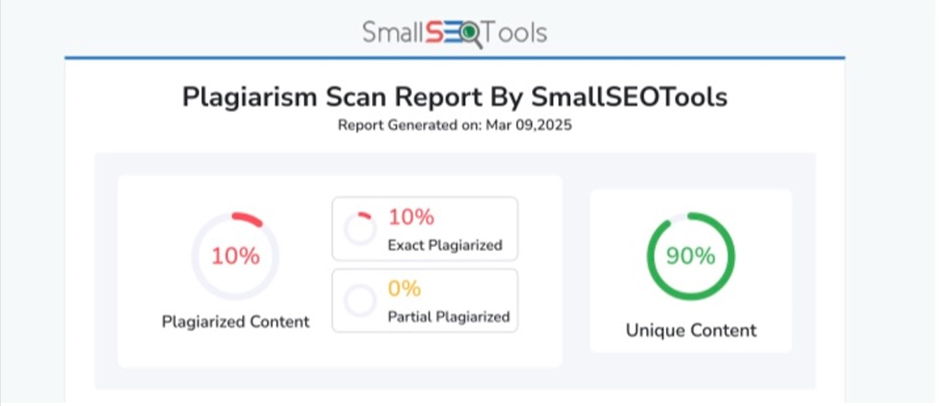
Report Generated on: Sept 28, 2025

